Email Validation API

📧 What Is an Email Validation API?
# Source: Chatgpt (GPT-5-Mini) at [1/19/2026]
An Email Validation API is a web service that checks whether an email address is real, valid, and safe to use — before you store it, send to it, or let it register.

✅ What It Can Do
# Source: Chatgpt (GPT-5-Mini) at [1/19/2026]
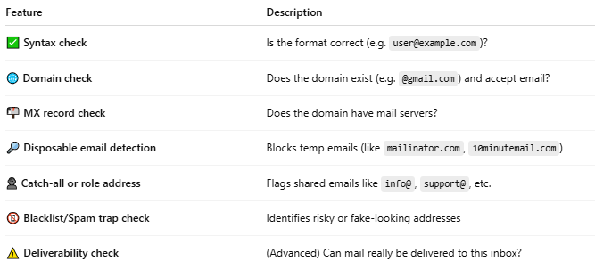

Feature | Description
✅ Syntax check | Is the format correct (e.g. user@example.com)?
🌐 Domain check | Does the domain exist (e.g. @gmail.com) and accept email?
📬 MX record check | Does the domain have mail servers?
🔎 Disposable email detection | Blocks temp emails (like mailinator.com, 10minutemail.com)
👤 Catch-all or role address | Flags shared emails like info@, support@, etc.
📵 Blacklist/Spam trap check | Identifies risky or fake-looking addresses
⚠️ Deliverability check | (Advanced) Can mail really be delivered to this inbox?

📤 Example Request (to an Email Validation API)
# Source: Chatgpt (GPT-5-Mini) at [1/19/2026]
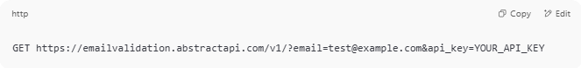
GET https://emailvalidation.abstractapi.com/v1/?email=test@example.com&api_key=YOUR_API_KEY

🧪 Example Response
# Source: Chatgpt (GPT-5-Mini) at [1/19/2026]
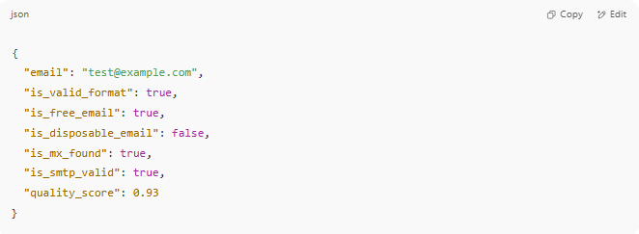

{
"email": "test@example.com",
"is_valid_format": true,
"is_free_email": true,
"is_disposable_email": false,
"is_mx_found": true,
"is_smtp_valid": true,
"quality_score": 0.93
}

🧩 Popular Email Validation APIs
# Source: Chatgpt (GPT-5-Mini) at [1/19/2026]
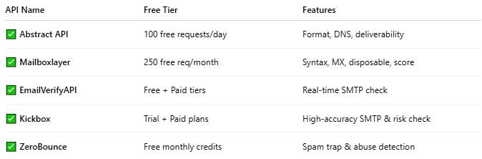

API Name | Free Tier | Features
✅ Abstract API | 100 free requests/day | Format, DNS, deliverability
✅ Mailboxlayer | 250 free req/month | Syntax, MX, disposable, score
✅ EmailVerifyAPI | Free + Paid tiers | Real-time SMTP check
✅ Kickbox | Trial + Paid plans | High-accuracy SMTP & risk check
✅ ZeroBounce | Free monthly credits | Spam trap & abuse detection

🔐 Why Use an Email Validation API?
# Source: Chatgpt (GPT-5-Mini) at [1/19/2026]
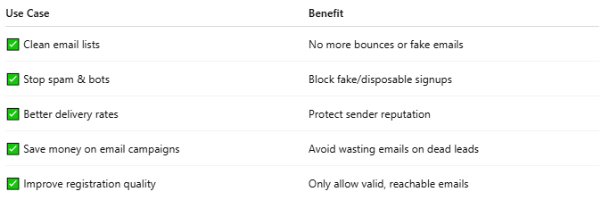

Use Case | Benefit
✅ Clean email lists | No more bounces or fake emails
✅ Stop spam & bots | Block fake/disposable signups
✅ Better delivery rates | Protect sender reputation
✅ Save money on email campaigns | Avoid wasting emails on dead leads
✅ Improve registration quality | Only allow valid, reachable emails

🛠 How to Test One (Free)
# Source: Chatgpt (GPT-5-Mini) at [1/19/2026]
- Choose a provider like:
  - https://www.abstractapi.com/email-verification
  - https://mailboxlayer.com
- Sign up (free key)
- Make a test call in:
  - Postman
  - Browser (GET requests)
  - PHP / JavaScript code

